<https://datawrapper.dwcdn.net/vxO0s/1/>

When it comes to junk food, cookies cost the most, especially on the East Coast. An analysis of unit prices among various junk foods reveals that cookies cost the most per unit in Boston, while they cost the least in San Diego.

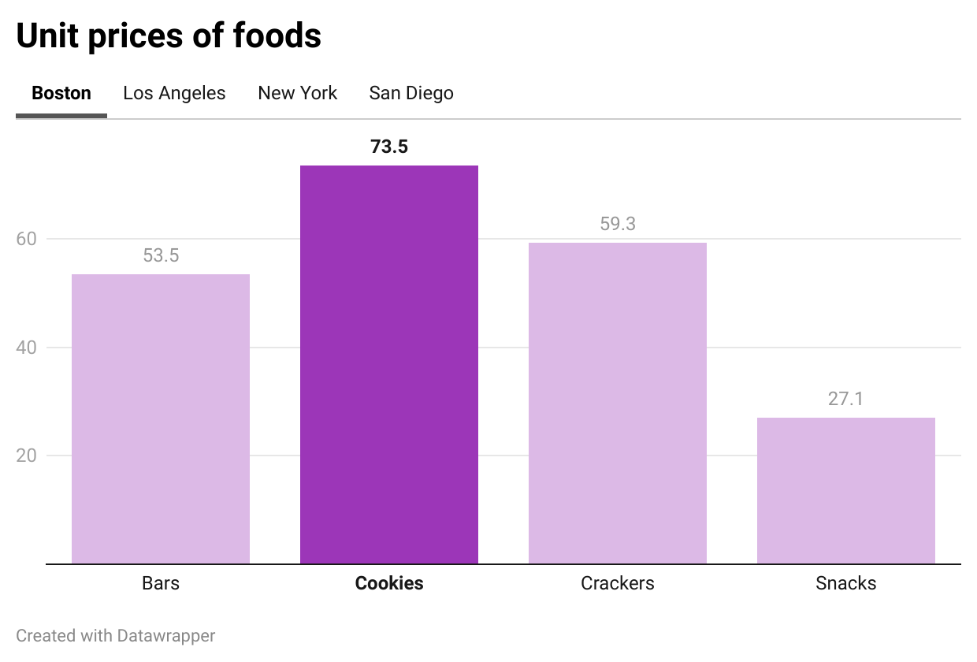

In New York and Los Angeles the competition grows stiff among junk foods as bars cost only slightly less per unit than cookies do.

Overall crackers cost less on the West coast than they do among East coast cities. For example, in Boston crackers cost more than bars, though they still cost less than cookies.

San Diego stands as the cheapest city for cookies, though the sweets remain the most expensive junk food per unit. San Diego also boasts the cheapest crackers as the data reveals junk food costs less in San Diego than it does in L.A.

Boston stands apart as the most expensive city for junk food, even beating out New York. The costs of crackers in New York cost significantly less than in Boston. However, Manhattan style clam chowder is more likely to need crackers to begin with. Boston clam chowder with crackers is a luxury in terms of unit price per cracker, but the chowder tastes better on its own so the need for crackers may be less than with Manhattan.

<https://datawrapper.dwcdn.net/oGnCi/1/>